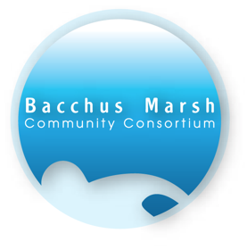

The Bacchus Marsh Aquatic Centre Community Consortium Inc is a community driven organisation formed to provide leadership in raising awareness of the need for an aquatic centre and facilitating its successful achievement. It is also the body charged with the responsibility for raising $1,000,000 to contribute to the design and construction costs of the facility by Moorabool Shire Council.

The Plan
The new indoor sports and aquatic centre will:
- Be located on land purchased by Moorabool Shire at the corner of Fiskens and Tavener Streets adjacent to Maddingley Park for this purpose.
- Be served by public transport, the pool’s positioning close to major thoroughfare for ready use by train commuters, schools, hospital, and general public. With room for parking of over 200 cars.
- Have the following design features: 4 Court basketball stadium, 25 metre lane lap pool, toddlers pool, learn to swim pool, kitchen/café, change rooms, consulting rooms for hire by therapists, general purpose room as a gymnasium, plant room and associated pool infrastructure, tiered seating, crèche, private facilities for nursing mothers, and much more !!
- Be available 24/7 all year; and offer programs and classes at affordable rates to meet demand for all indoor sports, learn-to-swim, health and fitness classes, and therapeutic and rehabilitation programs
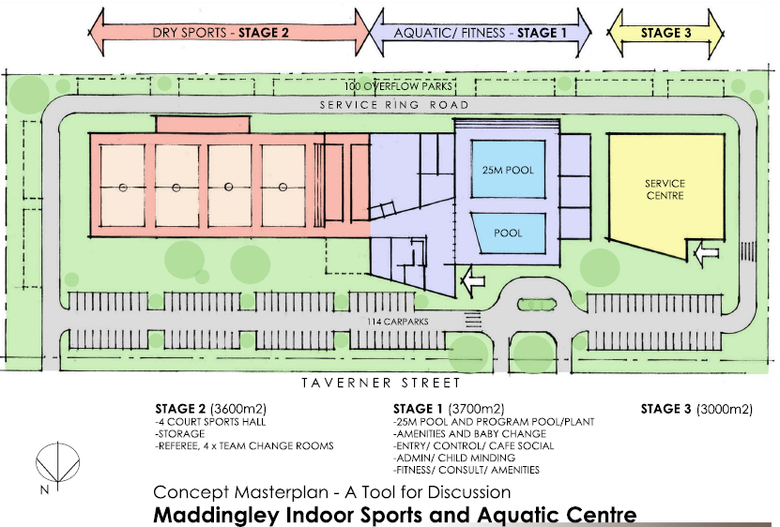

Current Status
Moorabool Shire Council is responsible for the development of the Maddingley Indoor Sports and Aquatic Centre. It is projected that total cost will be $25,000,000 with state and federal government grants, the Shire’s own contribution, Community fund-raising and potential Partners contributing to the cost.

It is hoped that the final plans can be developed by 2020 and that work will commence in 2022.

The Bacchus Marsh Community Consortium Inc, is undertaking a variety of activites to assist the Shire to raise the necessary funding.

To achieve our $1m commitment, our revenue sources include:
- Bacchus Marsh Flower & Garden Show The 2018 Bacchus Marsh Flower & Garden Show will be held on 20th & 21st October 2018. This Event is now in it’s 5th year and has raised about $30,000 towards our ongoing program of fund raising .
- Residual funds from earlier community events, tagged for charitable purposes
- Major Patrons – local benefactors known to be in support of the aquatic centre and in a position to make a major donation
- Community Service Initiatives – Lions and Rotary in Bacchus Marsh and Ballan are active in their fund-raising. One initiative is to achieve land donated by a local housing developer, construction at base rates, auction, and proceeds to the aquatic centre
- User Groups’ Fund-Raising Initiatives – including pre-schools, kindergartens and 9 schools, a range of sport based clubs and associations in the broader district, users of the associated leisure centre in Bacchus Marsh and its provider Belgravia Leisure Pty Ltd
- Grants – various sources through government departments and a range of community organisations supportive of sport, health, wellness, safety with funds available on application from not-for-profit organisations
- Sponsorship and Donations – invitations to local and regional businesses, and to other major organisations that see commercial benefit in supporting the project.

