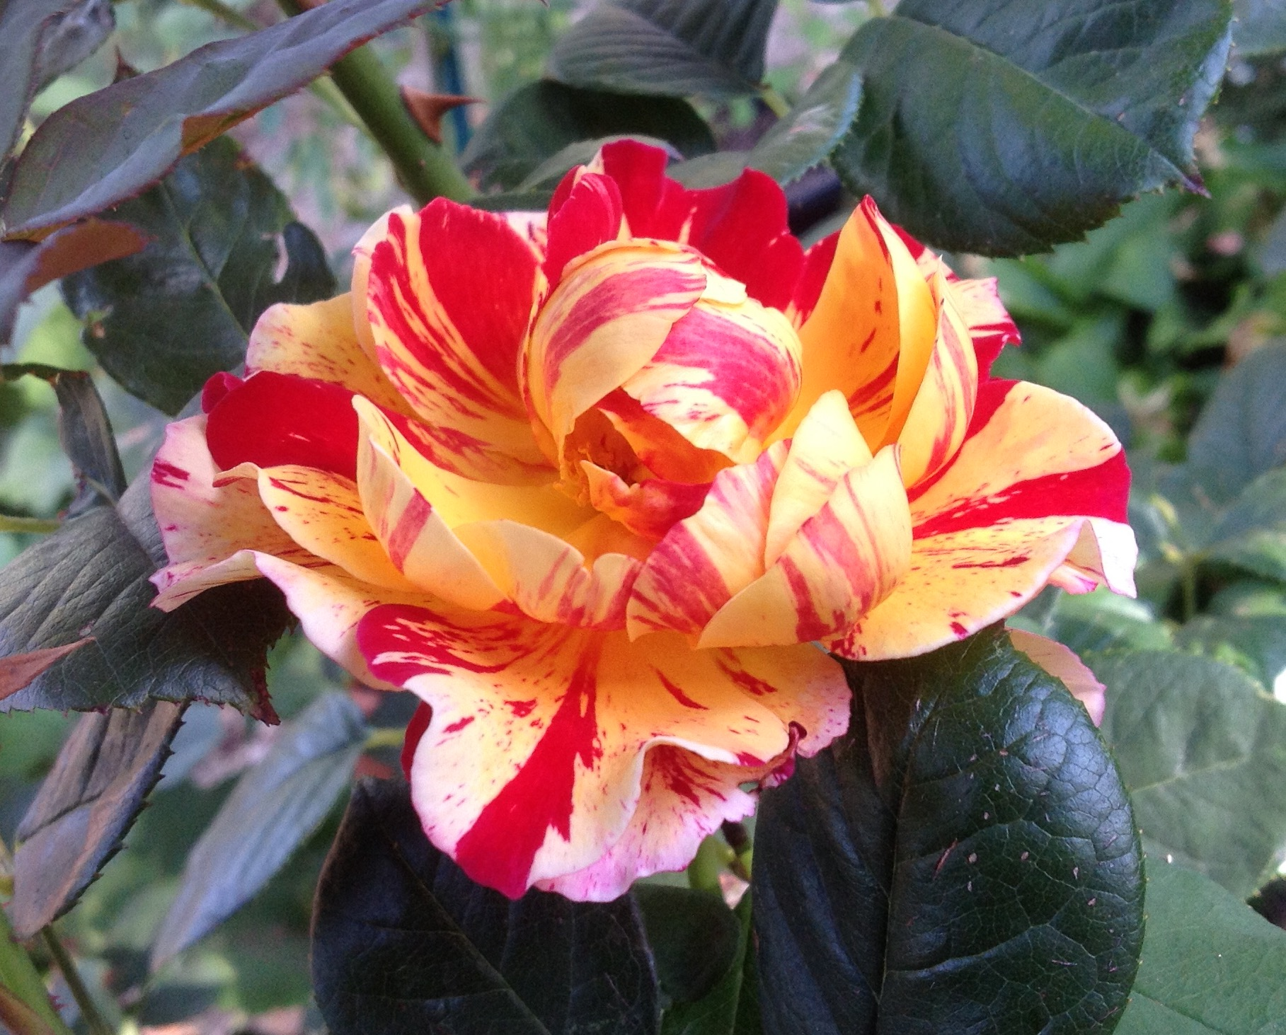

Photography

Competition

Photography Entry Form

Please submit your Entry Form before the 20th October. (See Information)

Fees to be paid at the Entry Desk when entries are submitted.

|  |  |  |
| --- | --- | --- |
| **Section**  **i.e.** | **Details of Entry**  **i.e.** | **Entry Fee**  $2 adult  $1 Junior |
| 2 | A Photograph of a Tree | $2 |
| 6 | A Photograph of a Garden | $2 |
|  |  |  |
|  | **Fill out your entry/entries below.** |  |
|  |  |  |
|  |  |  |
|  |  |  |
|  |  |  |
|  |  |  |
|  |  |  |
|  |  |  |
|  |  |  |
|  | **TOTAL** | **$** |

**First Name:** ……………………………………………… **Last Name:** …………………………………………………

**Postal Address:** …………………………………………………………………………………………………………………

…………………………………………………………………………………………………………………

**Post Code:** ………………………………….. **Phone:** ……………………………………………………………..

**Email Address:** …………………………………………………………………………………………………………………..

**Enquiries: Kate Tubbs**

**0400 063 466**

Section 1.

* **A Photograph of a Tree or Shrub, 16 & Under**

Section 2.

* **A Photograph of a Tree or Shrub, Over 16**

Section 3.

* **A Photograph of a Flower, 16 & Under**

Section 4.

* **A photograph of a Flower, Over 16**

Section 5.

* **A Photograph of a Garden, 16 & Under**

Section 6.

* **A Photograph of a Garden, Over 16**

Information:

1. Entry Forms must be submitted online or posted before Friday, October 20th

Online: katetubbs@hotmail.com

Post: PO Box 343, Bacchus Marsh, 3340

1. Entry Fees: $2 Adults, $1 Children under 16.
2. Entries must be mounted on card, not framed.
3. Entries must be A3 size or under.
4. Entries to be delivered to the Public Hall between 3.00p.m. - 5.00p.m. Friday 27th October.
5. Entries will be judged before the Show opens at 12 noon on Saturday the 28th October.
6. Entries to be picked up between 4.00p.m. - 5.00p.m. Sunday 29th unless special arrangements have been made with the committee beforehand.
7. Ribbons will be awarded for 1st 2nd 3rd places in each Section.